**EXPERIMENT 1**

**AIM:**

**A. Prepare a resume using HTML tags**

**CODE:**

<!DOCTYPE html>

<html lang="en">

<head>

    <meta charset="UTF-8">

    <meta name="viewport" content="width=device-width, initial-scale=1.0">

    <title>Resume</title>

</head>

<body>

    <div>

        <div style="width: 30%; float: left; padding: 20px; box-sizing: border-box;">

            <div style="text-align: center;">

                <img src="resumeimg.jpeg" alt="Profile Picture" style="width: 100%; border-radius: 50%; margin-bottom: 20px;">

            </div>

            <div>

                <h3>Contact</h3>

                <p>91+ 7900036308</p>

                <p>vu4f2223120@pvppcoe.ac.in</p>

                <p>Godrej Creek Side, Vikhroli (East), Mumbai</p>

            </div>

            <div>

                <h3>Education</h3>

                <table style="width: 100%; border-collapse: collapse;">

                    <thead>

                        <tr>

                            <th style="border: 1px solid #ddd; padding: 8px;">Year</th>

                            <th style="border: 1px solid #ddd; padding: 8px;">School/College</th>

                        </tr>

                    </thead>

                    <tbody>

                        <tr>

                            <td style="border: 1px solid #ddd; padding: 8px;">2015 - 2020</td>

                            <td style="border: 1px solid #ddd; padding: 8px;">Udayachal High School</td>

                        </tr>

                        <tr>

                            <td style="border: 1px solid #ddd; padding: 8px;">2020 - 2022</td>

                            <td style="border: 1px solid #ddd; padding: 8px;">D.G Ruparel College Of Arts, Science & Commerce</td>

                        </tr>

                    </tbody>

                </table>

            </div>

            <div>

                <h3>Skills</h3>

                <ul>

                    <li>Project Management</li>

                    <li>Teamwork</li>

                    <li>Time Management</li>

                    <li>Kotlin (Basic)</li>

                    <li>C# (Basic)</li>

                    <li>Unity Engine (Basic)</li>

                    <li>Unreal Engine (Basic)</li>

                </ul>

            </div>

            <div>

                <h3>Languages</h3>

                <ul>

                    <li>English</li>

                    <li>Marathi</li>

                    <li>Hindi</li>

                </ul>

            </div>

        </div>

        <div style="width: 70%; float: right; padding: 20px; box-sizing: border-box;">

            <h1>SHUBHAM NAVNATH KUMBHAR</h1>

            <div>

                <h3>Profile</h3>

                <p>I am an IT student with a strong passion for game development. Despite it not being a widely recognized field in India, I am determined to make a significant impact and carve out a successful career in this industry. My goal is to create high-quality games that gain recognition worldwide. I am committed to continuously learning and growing in this field to achieve my dream of putting both my name and my country on the global map.</p>

            </div>

            <div>

                <h3>Computer Languages</h3>

                <p><strong>C (Programming Language)</strong></p>

                <ul>

                    <li>Exploring the variants of C (C#, C++).</li>

                    <li>Tried Unity Game Engine with C#.</li>

                    <li>Made a small scene in Unreal Game Engine with C++.</li>

                </ul>

                <p><strong>Java (Programming Language)</strong></p>

                <ul>

                    <li>Exploring Advanced Java & DSA with Java.</li>

                    <li>Implemented a basic application using Java.</li>

                    <li>Developed a Weather Forecast project with a team.</li>

                </ul>

                <p><strong>Python (Programming Language)</strong></p>

                <ul>

                    <li>Exploring Game Development with Python using 'PyGame'.</li>

                    <li>Developed a Gesture Based Interface project with a team.</li>

                </ul>

            </div>

            <div>

                <h3>Extras</h3>

                <p><strong>Kotlin</strong></p>

                <ul>

                    <li>Familiar with basics of Kotlin.</li>

                </ul>

                <p><strong>Unity Engine</strong></p>

                <ul>

                    <li>Familiar with basics of making a scene.</li>

                </ul>

                <p><strong>Unreal Engine</strong></p>

                <ul>

                    <li>Familiar with sprites and flipbooks to develop character animation.</li>

                </ul>

            </div>

            <div>

                <h3>Interests</h3>

                <p><strong>Gaming</strong></p>

                <ul>

                    <li>Fond and familiar with many video games</li>

                </ul>

                <p><strong>Augmented Reality/Virtual Reality</strong></p>

                <ul>

                    <li>High interest in learning AR/VR Space</li>

                </ul>

            </div>

        </div>

    </div>

</body>

</html>

**OUTPUT:**

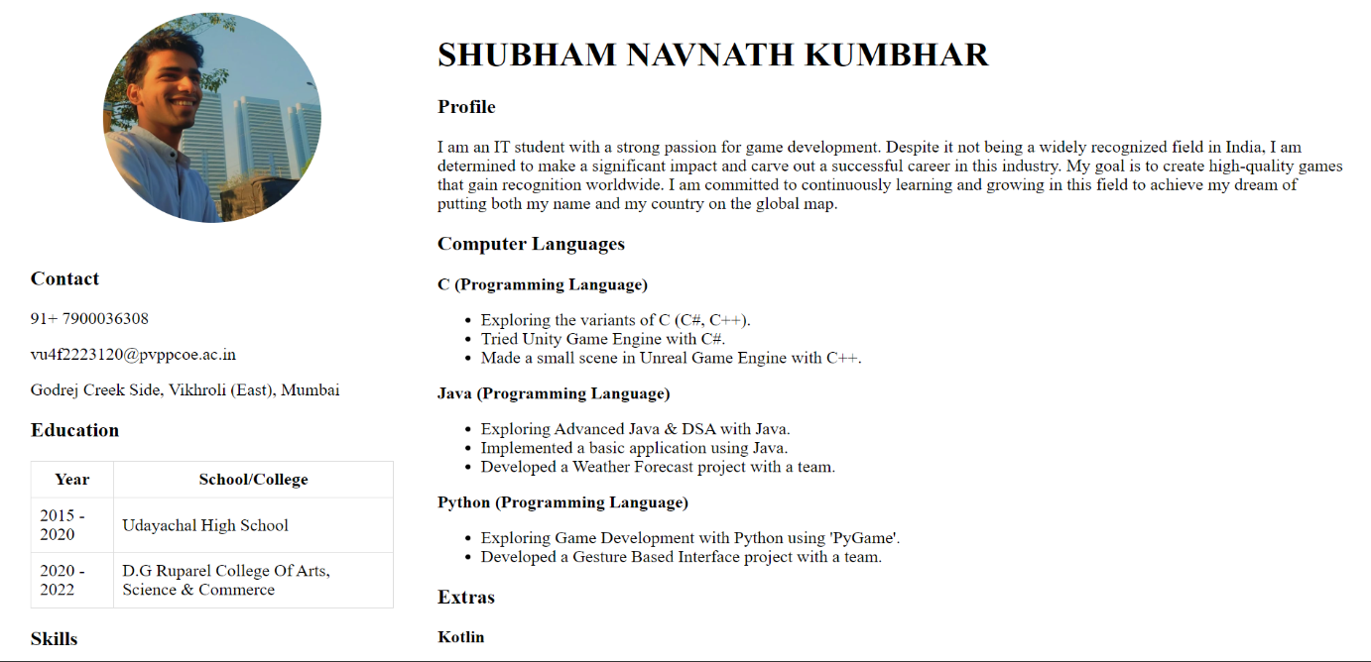

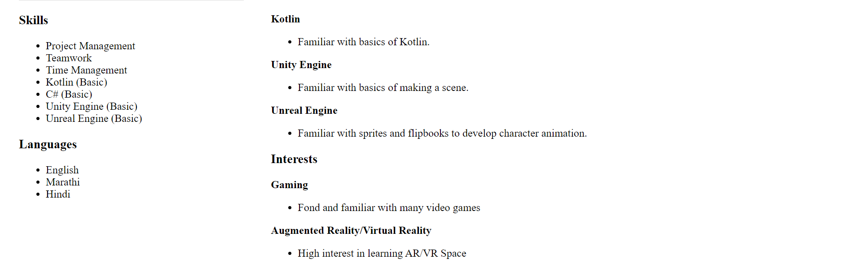

**B. Design a registration form with HTML5 form tags**

**CODE:**

<!DOCTYPE html>

<html lang="en">

<head>

    <meta charset="UTF-8">

    <meta name="viewport" content="width=device-width, initial-scale=1.0">

    <title>Registration Form</title>

</head>

<body>

    <div style="max-width: 600px; margin: 0 auto; padding: 20px; border: 1px solid #ddd; border-radius: 8px; background-color: #f9f9f9;">

        <h1 style="text-align: center;">Registration Form</h1>

        <form>

            <div style="margin-bottom: 15px;">

                <label for="name" style="display: block; font-weight: bold;">Full Name:</label>

                <input type="text" id="name" name="name" required style="width: 100%; padding: 8px; border: 1px solid #ccc; border-radius: 4px;">

            </div>

            <div style="margin-bottom: 15px;">

                <label for="contact" style="display: block; font-weight: bold;">Contact Number:</label>

                <input type="tel" id="contact" name="contact" required style="width: 100%; padding: 8px; border: 1px solid #ccc; border-radius: 4px;">

            </div>

            <div style="margin-bottom: 15px;">

                <label for="guardian_name" style="display: block; font-weight: bold;">Guardian's Name:</label>

                <input type="text" id="guardian_name" name="guardian_name" required style="width: 100%; padding: 8px; border: 1px solid #ccc; border-radius: 4px;">

            </div>

            <div style="margin-bottom: 15px;">

                <label for="guardian_job" style="display: block; font-weight: bold;">Guardian's Job:</label>

                <input type="text" id="guardian_job" name="guardian_job" required style="width: 100%; padding: 8px; border: 1px solid #ccc; border-radius: 4px;">

            </div>

            <div style="margin-bottom: 15px;">

                <label for="email" style="display: block; font-weight: bold;">Email:</label>

                <input type="email" id="email" name="email" required style="width: 100%; padding: 8px; border: 1px solid #ccc; border-radius: 4px;">

            </div>

            <div style="margin-bottom: 15px;">

                <label for="username" style="display: block; font-weight: bold;">Username:</label>

                <input type="text" id="username" name="username" required style="width: 100%; padding: 8px; border: 1px solid #ccc; border-radius: 4px;">

            </div>

            <div style="margin-bottom: 15px;">

                <label for="password" style="display: block; font-weight: bold;">Password:</label>

                <input type="password" id="password" name="password" required style="width: 100%; padding: 8px; border: 1px solid #ccc; border-radius: 4px;">

            </div>

            <div style="margin-bottom: 15px;">

                <label for="dob" style="display: block; font-weight: bold;">Date of Birth:</label>

                <input type="date" id="dob" name="dob" required style="width: 100%; padding: 8px; border: 1px solid #ccc; border-radius: 4px;">

            </div>

            <div style="margin-bottom: 15px;">

                <label for="photo" style="display: block; font-weight: bold;">Profile Photo:</label>

                <input type="file" id="photo" name="photo" accept="image/*" style="display: block;">

            </div>

            <div style="margin-bottom: 15px;">

                <label for="signature" style="display: block; font-weight: bold;">Signature Photo:</label>

                <input type="file" id="signature" name="signature" accept="image/*" style="display: block;">

            </div>

            <div style="margin-bottom: 15px;">

                <label style="display: block; font-weight: bold;">Gender:</label>

                <label><input type="radio" name="gender" value="male" required> Male</label>

                <label><input type="radio" name="gender" value="female" required> Female</label>

                <label><input type="radio" name="gender" value="other" required> Other</label>

            </div>

            <div style="margin-bottom: 15px;">

                <label for="education" style="display: block; font-weight: bold;">Education:</label>

                <input type="text" id="education" name="education" required style="width: 100%; padding: 8px; border: 1px solid #ccc; border-radius: 4px;">

            </div>

            <div style="margin-bottom: 15px;">

                <label for="interests" style="display: block; font-weight: bold;">Interests:</label>

                <textarea id="interests" name="interests" rows="4" style="width: 100%; padding: 8px; border: 1px solid #ccc; border-radius: 4px;"></textarea>

            </div>

            <div style="text-align: center;">

                <button type="submit" style="padding: 10px 20px; background-color: #007bff; color: white; border: none; border-radius: 4px; cursor: pointer;">Submit</button>

            </div>

        </form>

    </div>

</body>

</html>

**OUTPUT:**

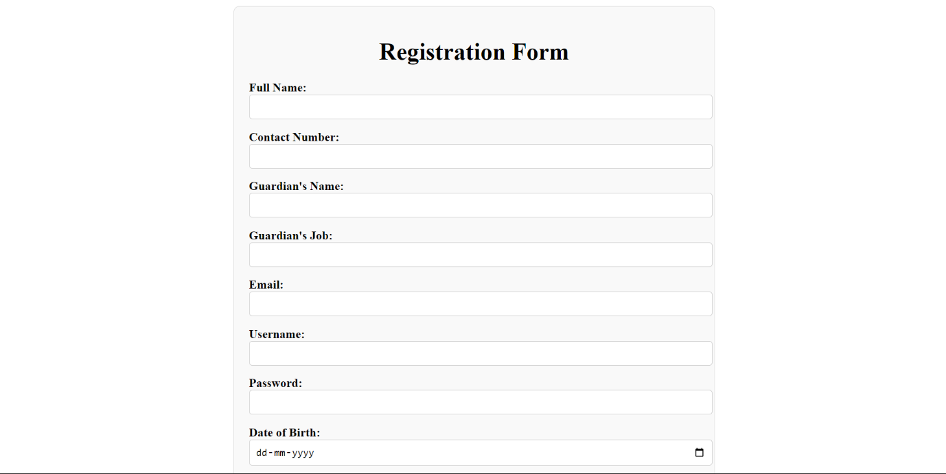

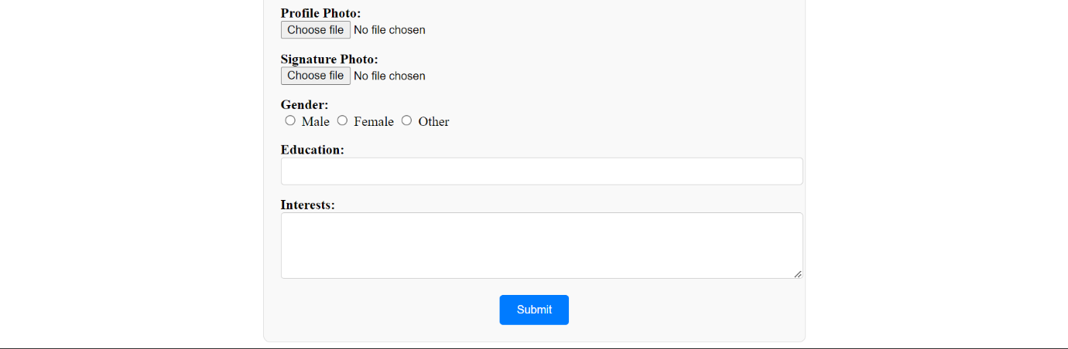

**CONCLUSION:** Hence, we have successfully implemented a resume with HTML tags and registration form with HTML5 form tags